Theory of Change: The Education Portfolio
Education is a fundamental human right and a prerequisite for inclusive economic growth and sustainable development. Norad’s education portfolio will support all relevant actors in their efforts to develop strong education systems that ensure learning for all. Solving the learning crisis will only be possible when countries’ own education systems are able to uphold their duty to deliver on the right to education.
The global community has committed to SDG4 - ensuring inclusive education for all. Achieving SDG4 is essential to achieve progress on many of the other Sustainable Development Goals, including no poverty, zero hunger, good health and gender equality. Research has consistently shown a strong connection between education and economic growth. Increased learning enhances individuals' human capital, thereby improving productivity and innovation, which are key drivers of economic growth.
The learning crisis is multifaceted, encompassing both access and quality issues. More than 251 million children and youth are out of school, many of whom are in areas with crisis and conflict. There is also a learning crisis, with only 58% of students globally reaching minimum proficiency level in reading and 44% in mathematics at the end of primary school. 1 The fact that the majority of children who are not learning, are already in school, highlights the need to improve education quality. Global demographic shifts, especially in the global south, require urgent action in skills development for the growing youth population.
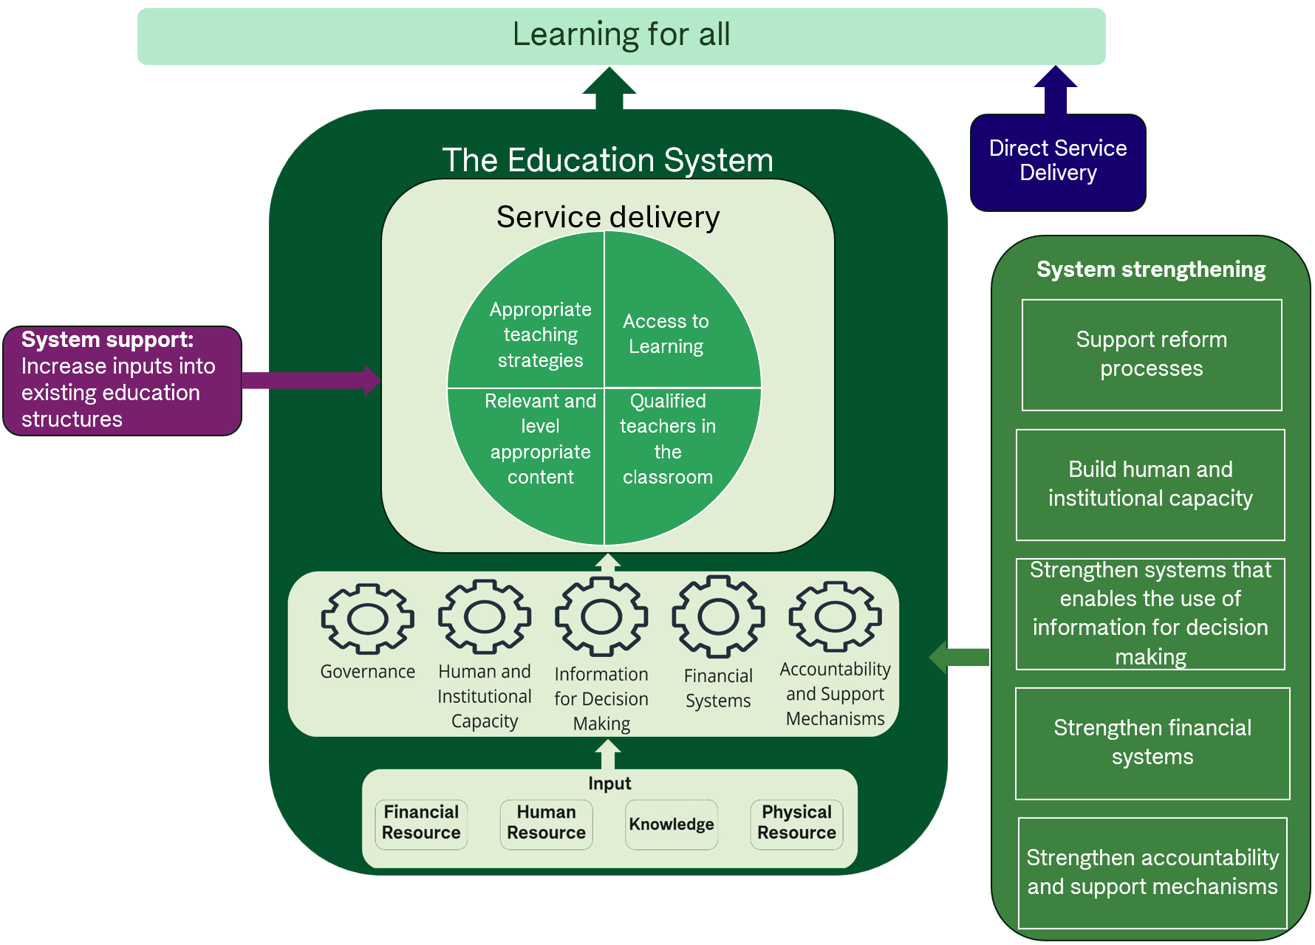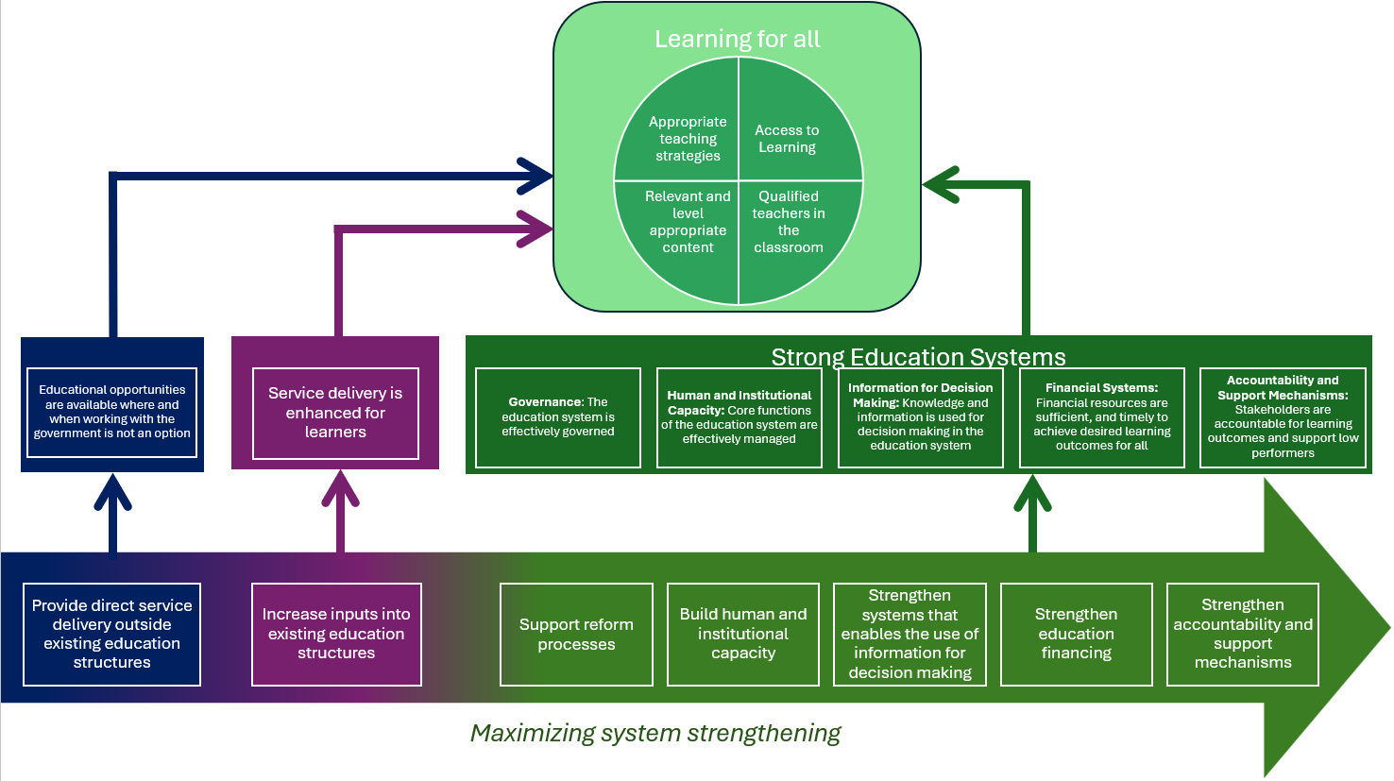
Impact:
The goal of the education portfolio is to ensure learning for all.
To achieve this, interventions need to influence what happens in the classroom to improve learning outcomes. In addition, key assumptions need to be in place for interventions to create lasting impact. These assumptions are appropriate teaching strategies, relevant and level appropriate content, access to learning (both access to schooling and children’s capacity to learn) and qualified teachers in the classroom.
Outcomes
Improving learning outcomes can be achieved by three pathways (See figures with colour coding). Norad’s portfolio management aims to maximize system strengthening interventions.
Pathway 1: System strengthening
Partners enhance the system capacity and ability to transform inputs into high quality service delivery to all children, while promoting national leadership and ownership of the education system.

Governance
Outcome 1 The education system is effectively governed
Intervention category: Support reform processes
Support reform processes necessary to ensure effective governance, including:
- Development and implementation of policies, laws, regulations, standards and guidelines necessary to ensure access to basic education and that the education is of good quality
- Improve management of core functions of the education systems
- Ensure clear roles and responsibilities within educational management/leadership
- Improve quality assurance systems
- Curriculum development and management

Human and Institutional Capacity
Outcome 2: Core functions of the education system are effectively managed
Intervention category: Build human and institutional capacity
Support development of institutions necessary to ensure quality education for all
- Strengthen the institutional capacity of teacher education institutions
- Strengthen capacity for innovation and research to improve learning for all.
- Enhance the human and institutional strength of the management system
- Support development and strengthening of other specialized institutions that are necessary to ensure quality basic education for all

Information for Decision Making
Outcome 3: Knowledge and information are collected and used by relevant stakeholders for decision making in the education system.
Intervention category: Strengthen systems that enable the use of information for decision making
- Support establishment of Education Management Information Systems (EMIS) for collection, processing, maintenance and dissemination of information to support decision-making
- Build capacity for evidence generation and use
- Improve availability and use of context- appropriate learning assessment tools

Financial systems:
Outcome 4: Governments ensure that financial resources are sufficient, timely, and need-based to achieve desired learning outcomes for all.
Intervention category: Strengthen financial systems to ensure that sufficient resources, are at the right time and place, to achieve desired learning outcomes
- Increase financial adequacy including influencing governments to prioritize adequate budget allocations to education
- Increase financial efficiency build competence for efficient allocation and management of resources to support educational initiatives. This also includes improving donor efficiency.
- Increase financial equity: including gender responsive budgeting

Accountability and Support Mechanisms
Outcome 5: Stakeholders promote accountability for learning outcomes​ and support low performers.
Intervention category: Strengthen accountability and support mechanisms
- Strengthen community engagement including strengthening civil society to ensure accountability, development of local solutions and community ownership
- Strengthen systems for stakeholder involvement including strengthen systems within the government to ensure stakeholders get involved in decision making
- Support stakeholder involvement including policy development through social dialogue
Pathway 2: System support
Our partners can support education systems by aligning their work with the existing education system
Outcome 6: Service delivery is temporarily enhanced to improve learning
Intervention category: Increase the level of input into existing education structures
Directly improve children’s access to learning including conducting information campaigns in communities to ensure school enrollment, providing psychosocial support to children, build or improve infrastructure.
- Directly train or mentor teachers.
- Directly improve teaching strategies including implementing standardized teaching methods
- Directly ensure that relevant, level-appropriate content is taught.
- Directly support children’s access to school, such as through information campaigns, accelerated learning with the goal of reintegrating the children in formal schools etc.
- Sector budget support
- Provide data and analysis of the education sector through external actors.
Pathway 3: Direct service delivery
Outcome 7: Educational opportunities are available where and when working with the government is not an option
Intervention category: provide education services
This can include directly delivering education serviced to a specific population group that is systematically excluded from the existing system or when and where Norway has an active policy not to strengthen the de facto governments. This can include that we support partners in operating schools, providing accelerated learning programs or other forms of direct service delivery.

UNESCO (2024). Global Education Monitoring Report 2024/5: Leadership in Education – Lead for Learning; Paris, UNESCO

