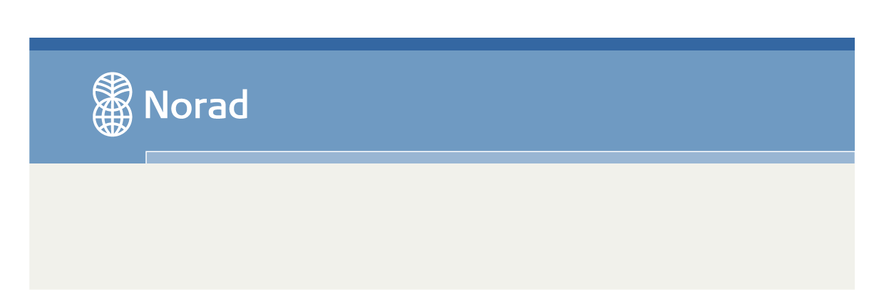
Civil Society Support
Her begynner teksten…
UPDATED IMPLEMENTATION PLAN AND BUDGET FORM

(Deadline for submission: Reference to current agreement)

The form for updated implementation plan and budget is used to document changes to plans and budgets for the coming period compared to the plan on which the agreement with Norad is based.

The form should be completed with reference to the agreement and approved plans. Grant recipients may use their own formats as long as all items in the form are included. In the form, ‘the Project’ refers to the entire intervention encompassed by the agreement with Norad, be it a project, programme or a portfolio of projects/programmes.

1. General

1.1 | Name of the grant recipient:
1.2 | Norad’s agreement number:
1.3 | Norad’s agreement name:
1.4 | Agreement period (from year through year):
1.5 | Annual plan for the year:

2. Significant changes to plans, budgets and organisation

Significant changes to the Project primarily encompass changes that require approval by Norad according to the grant recipient’s prevailing agreement. It is therefore advisable to check the wording of the agreement.

Give a brief account of the changes. The nature of the changes must be clearly described, along with their consequences for the Project and the reasons for the changes.

3. New projects/programmes, if appropriate

Normally, there is no allowance for the establishment of new projects/programmes during an agreement period. However, extraordinary situations may arise in which a project/programme must be phased out or changed to such an extent that the changes may appear to constitute a new project/programme. Examples of such situations may be new political frameworks or wars and conflicts in the recipient country.

The wording of the grant recipient’s prevailing agreement will show how the organisation should proceed in such cases, for example whether a written invitation from Norad will be required.

4. Budget – financial need – grants from the Norwegian MFA/Norwegian embassies

4.1 The budget for the upcoming year shall follow the same budget structure as the last approved budget and include a comparison between the two, allowing for the identification of deviations.
4.2 If the Grant Recipient is planning to carryover funds from last year to the upcoming year this should be reflected in the budget when possible.
4.3 Please also provide an overview of any grants/grants applied for from the Norwegian Ministry of Foreign Affairs even though they are not related to the project. If these potential grants are integrated in the project budget it is not necessary with a separate overview over these funds.
4.4. Grant Recipients with agreements containing sub-units in Norad’s internal systems shall also provide an updated form for statistical classification of programmes/projects.

5. Results monitoring and evaluation

Provide an overview of planned evaluations and reviews for the coming year:
For agreements that include sub-units, state the number of each sub-unit if possible.

Describe how the evaluations will be financed and their anticipated budget.

Date:

________________________
Name and signature
Title

