Oppdatert 11.11.2025.

Quick Guide - Filling out the «Form for statistical classification of programmes/projects»

General information
When filling out the form, please make sure the form includes information for the complete agreement period with Norad. The total amount shall always correspond to the amount disbursed from Norad in the respective year. The column for each year represents the cash-flow (payments) from Norad and not the budgeted expenses. However, the form must also be in accordance with the agreement with Norad and approved budget. For Norad’s systems to successfully import the forms, do not format/code cells or columns.

Each row represents the organisation’s/network’s “subunit”: a breakdown and more detailed information about each programme and/or project according to sectors and sub-sectors. How to code each programme, depends on its nature. At the same time, having many small subunits will complicate the breakdown. For new agreements, it is recommended to have an annual budget of a minimum of 1 million NOK per subunit.

PLEASE NOTE: Data will be published and reported to the OECD and others who publish granular data. If you have concerns about publishing particular projects from a health and safety perspective, i.e. local partners’ security or sensitive data in any other form, please contact your programme officer in Norad.

A programme may be coded as a single subunit or be divided into several subunits. For instance, if a programme has several components, it could be divided into several subunits depending on the size of the budget e.g.:
- If a project consists of educating teachers (DAC code 111.30) and food crop production (DAC code -311.61), the programme should be divided into two separate subunits.
- If a programme has activities in several countries, then it could also be divided into several subunits. An option is to mention all countries in the agreement description.
- It is not necessary to create a separate subunit for each implementing partner. It is sufficient to list the largest implementing partner for each subunit and then give information on the other partners in the the sub-agreement description.
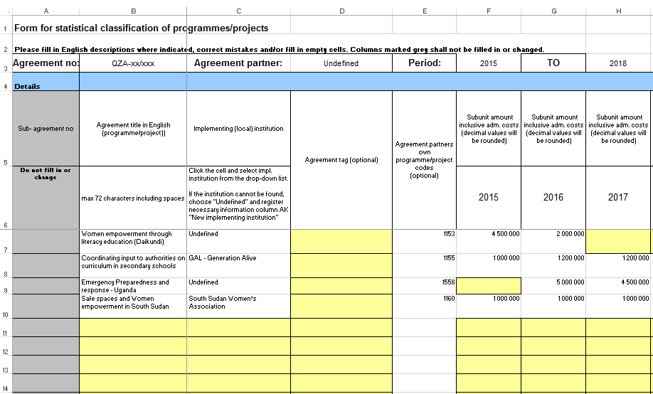
Figure 1 – An outline of Norad’s form. Each row represents one subunit. The form must include information about the agreement’s programmes and budget for the complete period.

Filling out the form for statistical classification of programmes and projects
The information to be filled in is mainly based on definitions agreed on by the OECD/DAC (Development Assistance Committee). For information about the categories and choices available, please use Norad's Statistical Classification Manual: https://norad.no/statisticsmanual.

Details
- Sub agreement no: The agreement numbers are automatically generated by Norad’s systems. Therefore, do not edit this column.
- Agreement title: Must be in English. Do not exceed 72 characters. Titles should be precise and informative. Avoid the use of abbreviations and colloquialisms/idioms.
  - Examples of good titles:
    - STEPS – Climate Change Impact – enhancing capacity of women
    - Learning from REDD+: Enhanced global comparative analysis
  - Examples of titles that should be avoided:
    - UN-REDD
    - PSE/TIPH HOM
    - Amendment no 4
- Implementing (local) institution: Click on the cell and select the right implementing (local) institution from the drop-down list. If the institution cannot be found, choose "Undefined" and register the necessary information under column AI "New implementing institution". Use the institution’s full name. Avoid abbreviations.
- Agreement tag (optional): For programmes that fit one of the agreement tags from the drop-down list. If several of the options are applicable, choose the most fitting tag. If none of the tags fit, leave the cell empty.
- Agreement partners own programme/project codes (optional): Not to be filled out
- Subunit amount inclusive admin. costs (decimals will be rounded): Totals must include administrative costs and be in accordance with approved budget/sum granted. Sums must be in Norwegian kroners (NOK). Avoid decimals and formatting/coding (e.g. =SUM( ) or =F7+G7+H7) when filling in the form.
- Sub-agreement period (4 digits): Fill in the first year (4 digits) and planned exit year (4 digits) under the agreement. E.g., if the agreement runs from 2025-2029, then the planned exit year should not exceed 2029.
- Sub-agreement description in English (Max 500 characters including spaces. All text for the same programme/project in the same cell. Description is reported to OECD/DAC): Like the agreement titles, the descriptions should give accurate and precise information about each programme. Avoid abbreviations. They must also justify the statistical coding, such as DAC sector codes, policy markers and SDGs. If the sub-agreement has more implementing institutions than the one that is registered, please mention the secondary institutions in the description. If the sub-agreement has a global or regional “Recipient country” you may, if possible, mention the countries involved in the description.

Statistical classifications
- DAC- sector. 3-digits for main sector & 2-digits for sub sector . The Statistical manual gives more information in English regarding DAC sectors: See Norad’s Statistical Classification Manual, Appendix 1 for more information.
- Recipient country: See Norad’s Statistical Classification Manual, Appendix 3 for more information.
- Form of assistance: The design and nature of the cooperation between the Norwegian government/Norad and cooperation/agreement partner. See Norad’s Statistical Classification Manual for more information (section 2.8).
- Policy marker (choose 0, 1 or 2 for relevant policy markers). The Statistical manual gives more information in English regarding policy markers: See Norad’s Statistical Classification Manual for more information (section 2.10).
- Focus areas (choose 0 or 1 for relevant focus areas). The Statistical manual gives more information in English regarding focus areas: See Norad’s Statistical Classification Manual for more information (section 2.11).

Other information
- Type of assistance: Automatically classified by Norad. Therefore, do not edit this column.
- New Implementing institution: For implementing institutions marked “Undefined” (ref. paragraph about “Implementing (local) institution”). Fill in the name of the new implementing institution according to the guidelines.
- Local institution: Not to be filled out.
- GPS coordinates: Not to be filled out.

Only relevant for Humanitarian Programmes
Humanitarian programmes are typically coded “720 Emergency response” with relevant sub-codes and policy markers as outlined in the Statistics Manual. However, other DAC-codes may also be relevant for certain responses such as “152.50 removal of landmines”.
Norway is committed to protection in humanitarian crises and armed conflict. To track Norway’s contributions Norad has introduced an “agreement tag” for “Protection (Incl. Child Protection and SGBV)”. Programmes in which protection is a significant component should use this agreement tag, selecting it from the dropdown menu in column E starting at cell 7. Please do not use any of the other available tags from the drop-down menu.
Agreement sub-unit structures should typically include at least one sub-unit per country. If protection work constitutes only a portion of the total activities in country X, two sub-units should be created (given that both sub-units have an annual budget of a minimum of 1 million NOK):
- One sub-unit tagged “Protection (Incl. Child Protection and SGBV)” reflecting the level of protection work in country X. Such subunits should include the text “Protection” in the “Agreement title” in column B.

- Another general sub-unit displaying the remaining program activities in country X (This subunit may contain the same statistical information, except for the agreement tag for protection).
Additionally, please include type of protection in the corresponding “Sub-agreement description” in column N. The three applicable protection categories are:
- General Protection
- Child Protection
- SGBV

